LIVE Teaching Development Fund Final Report:
'Can an intergrated physical and virtual library of anatomical cross sections and diagnostic images enhance anatomical knowledge, diagnostic image interpretation and spatial awareness?'
Dr Sarah Channon, Mr Andrew Crook, Miss Sarah Nicoll, Mrs Sonya Powney, Mr Ben Audsley and Professor Renate Weller.
Other contributors: Bethan Bryant, Fern Wilson, Jonathan Dixon, Daria Krajewska

Aims and Objectives
The specific aims of this project were:
- To enhance the teaching of anatomy and diagnostic imaging by creating a physical library of plastinated anatomical cross sections and a virtual library of diagnostic images, to be used in locomotor strand practical classes, for independent study, and during diagnostic imaging and equine rotations.
- To evaluate the resources by considering the effect of their use on anatomy learning, diagnostic image interpretation, and spatial ability of students.
The objectives were:
- To produce a set of serial plastinated cross sections of the equine distal limb
- To produce matching ultrasound, CT and MRI scans of the cadaveric limbs
- To make the diagnostic images available online as a virtual library, and to link each plastinated cross section with its reciprocal diagnostic image via QR scanning codes for easy access through mobile devices
- To integrate the resources into a Year 2 practical class (equine distal limb), and a Year 4 practical class (equine diagnostic nerve blocks), clinical skills stations (e.g. nerve block and joint block simulators) and in diagnostic imaging and equine rotations teaching
- To carry out a study considering the effect of the resources on anatomical knowledge, diagnostic image interpretation and spatial ability.
- To gather student feedback on their experiences using the resources and evaluate student enjoyment and confidence

Outputs
- A freely available Creative Commons licensed Equine Distal Limb resource, incorporating labelled transverse images of both fore and hind limbs, alongside matching CT, MRI and ultrasound images (Figure 1). The resource is web hosted but can also be downloaded and used offline using iSpring.
https://www.rvc.ac.uk/static/review/equine-distal-limb/index.html

- Serial sections of equine fore and hind limbs, plastinated and stored in sequence in the RVC anatomy museum (Figure 2). Sections are QR code linked to their respective page in the imaging resource.

- An abstract submitted to AMEE 2018:
Virtual or physical? 2D or 3D? The impact of resource design on learning outcomes in veterinary anatomy and diagnostic imaging teaching
Sarah Channon, Bethan Bryant, Fern Wilson, Sarah Nicoll, Sonya Powney and Renate Weller
- An abstract submitted to VetEd 2018:
Equine Distal Limb Anatomy and Imaging: Creation and Evaluation of an Open Access Educational Resource
Sarah Channon, Sonya Powney, Sarah Nicoll, Andrew Crook, Bethan Bryant, Fern Wilson, Daria Krajewska, Jonathan Dixon and Renate Weller

- A manuscript in preparation, for submission to Anatomical Sciences Education.

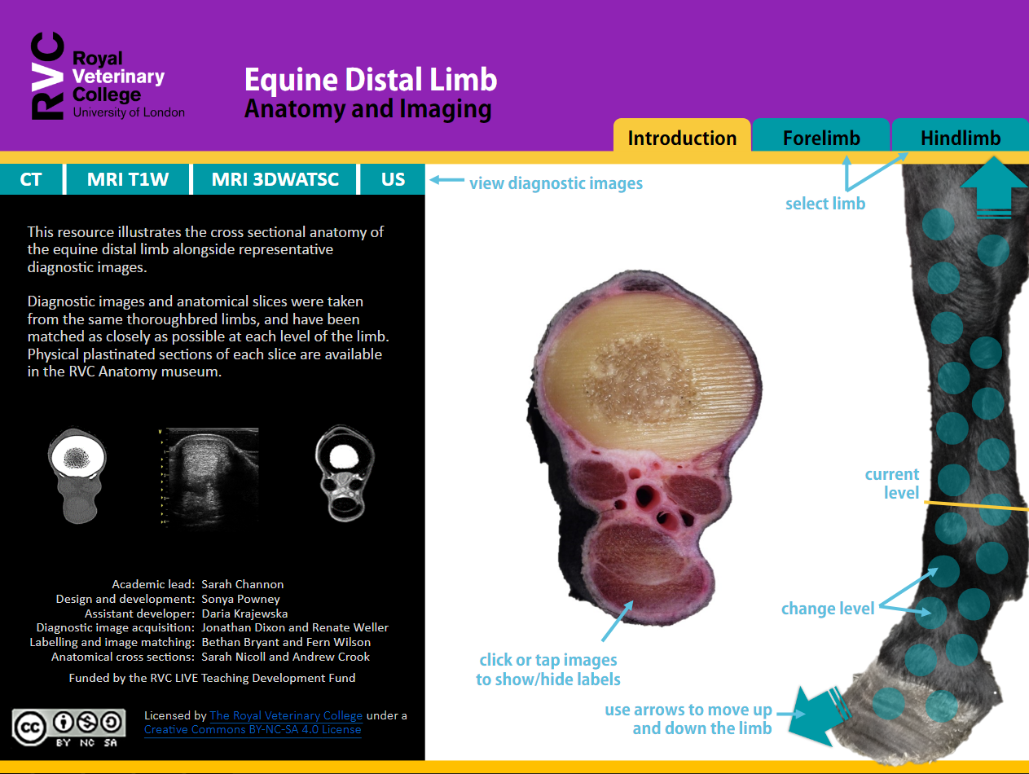
Figure 1: Front page of online Equine Distal Limb resource

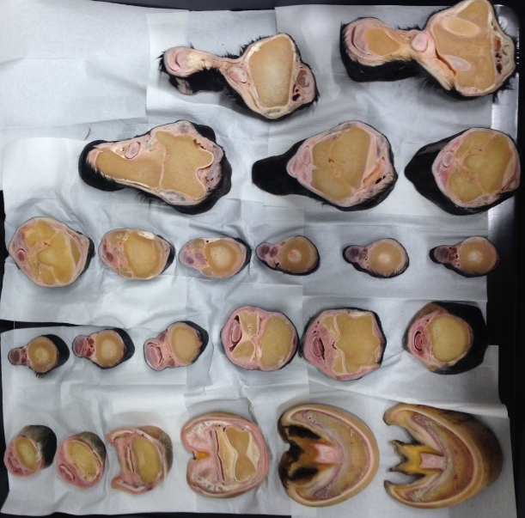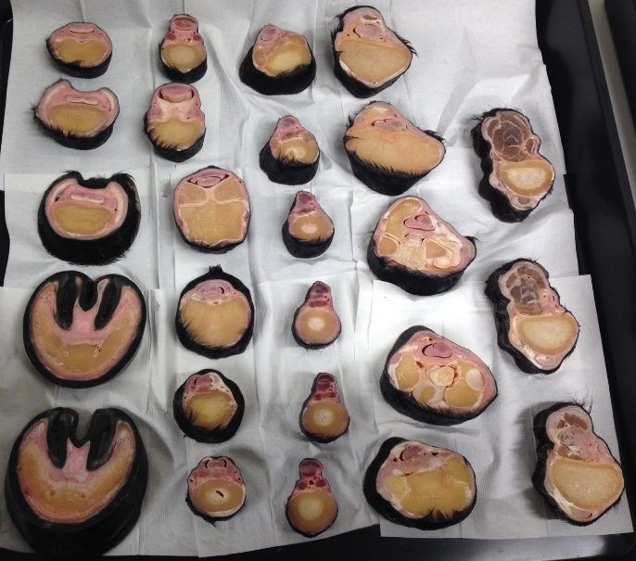
Figure 2: Plastinated cross sections of equine distal limbs available in the RVC Anatomy Museum

Summary of Study Results
We considered the use of the resources created by this project on student learning. Results indicated that resource type used affected student learning gains in specific areas, with largest improvements in anatomical knowledge in the group that learned using the online resource incorporating diagnostic images. This supports the idea that integrating clinical relevance such as diagnostic images into anatomy teaching enhances anatomy learning outcomes. Spatial ability of students appeared to influence the degree to which a student benefitted from a particular resource, with ‘high spatial' students appearing to benefit to a higher degree from the use of 3D physical specimens. This is key in the age of personalised learning and suggests that identifying strengths and weaknesses in particular personal skills/attributes may assist both staff and student in the selection of appropriate resources and/or learning activities.
Summary of Student Feedback
Students using the online resource reported improved knowledge development (p=0.04), understanding of 3D relations (p=0.045), ease (p=0.009) and enjoyment (p<0.0001) of use and that they would be more likely to use the resource for further study (p=0.002) than students that used other online resources. Student free comments on the resources were very positive, e.g. “Really enjoyed this session and found it very helpful. Great resource for working in small groups. I definitely know more than I ever have before, thanks!”; “The resource was incredibly useful. I feel I now have a much more solid understanding of anatomical structures in the equine limb.”
Discussion and Future Work
Choice of teaching method is important and ‘one size’ may not ‘fit all’ when deciding on which resources to use to support learning. A multimodal teaching approach may therefore be valuable in particular for subjects such as anatomy which require spatial skills and a ‘hands-on’ approach. We should consider developing further ways to reduce extraneous cognitive load when students with low spatial skills are learning to visualise and interpret three dimensional structures. As such how resources, such as those produced by this project, are incorporated in the curriculum needs careful consideration. Further consideration of methods to address and improve spatial skills of students in anatomy teaching is also needed.

