LIVE Teaching Development Team Award

"Vets: Fit for life!” Helping veterinary students to develop healthy exercise habits

The effect of an eight-week exercise programme on the psychological well-being of a group of self- selected ‘non-exercising’ veterinary students

Abstract
OBJECTIVE: The objective of this study was to determine the effect of an 8-week exercise programme on psychological wellbeing, work life balance, physical health and heart rate variability (HRV) in a group of ‘non-exercising’ veterinary students.
METHODS: 20 “non-sporty” students volunteered for this project. For 8 weeks they participated in 3 trainer-led session per week, each session lasting 45 – 60 minutes. Two sessions each week were fitness based, while the third session was sport based. A Shortened Stress Evaluation Tool (ASSET) survey was used to quantify perceived psychological wellbeing, work life balance and physical health both pre and post study. Steps, heart rate variability (HRV) and activity levels were measured throughout the programme.
RESULTS: Psychological wellbeing (p=0.004), work life balance (p=0.014) and physical health (p=0.01) improved significantly from the start to the end of the programme. No significant change in HRV pre- to post programme was found (p=0.549).
CONCLUSION: An 8-week training programme resulted in a significant improvement in psychological well-being in a cohort of selected people that do not frequently exercise and that have previously been shown to suffer from high levels of stress.

Abbreviations:
ASSET – A Shortened Stress Evaluation Tool
AVS – Association of Veterinary Students
BVA – British Veterinary Association
CDC – Centre for Disease Control
GHQ12 – General Health Questionnaire 12
HRV – Heart Rate Variability
HSE – Health and Safety Executive
MET – Metabolic Equivalent
NHS – National Health Service
RVC – Royal Veterinary College
UK – United Kingdom

Introduction
Mental wellbeing is a topic of increasing discussion within the veterinary profession. High suicide rates are often talked about (VetFutures 2015, Mellanby 2005, Agerbo et al. 2007), and researches have suggested vets are almost four times more likely than the general population to take their own life (Bartram and Baldwin 2010). While this may be true, and not to be overlooked, it may be just the tip of the iceberg. The issue of poor mental wellbeing within the industry is systemic. Of veterinarians working in the UK, 80% deemed the job as stressful (Robinson and Hooker 2006) and vets scored a poorer psychological wellbeing than most of the other 26 similar professions (Johnson et al. 2005). A more recent survey into new graduates found 22.2% (131/592) of respondents had suffered or are suffering with mental health problems, whilst 21.2% (130/592) had considered suicide within their lifetime (Halliwell et al. 2016).
For this study, we are focusing on mental wellbeing within a cohort of veterinary students.
Recent research has aimed to understand the extent to which veterinary students are experiencing mental ill health and possible reasons for this. A recent survey (2016) carried out across all UK vet schools by BVA and AVS published by Vet Futures indicated that 63% of Veterinary Students are currently, or have previously suffered from stress at university, a major factor contributing to poor mental wellbeing.
Students wellbeing (positive mental health) and mental ill health were quantified from a single UK Vet school and compared to the UK general population. 54% of respondents had experienced mental ill-health and students’ mental wellbeing was significantly poorer than general population estimates (Cardwell et al. 2013). Other significant differences between veterinary students and the general population included experiencing a higher degree of mental distress and were significantly more likely to have thought about suicide (Cardwell et al. 2013).
In the BVA/AVS survey in 2016 it was also revealed 27% of veterinary students are currently suffering from or have suffered from depression while at university and the same survey showed 83% of those claim their studies and deadline pressures a major factor while the second most prevalent factor was a lack of free time (58%).
Veterinary students are academic high achievers, many of whom have been focussed on becoming veterinarians from an early age (Heath et al 2006, Fraser et al 2008) often to the exclusion of other activities, including exercise (Cardwell & Lewis 2017). Recent RVC-based research even suggests that there is a tendency for veterinary students to postpone efforts to achieve a work life balance until after qualifying (Cardwell & Lewis 2017). Studying goes before anything else, and it requires a change in mindset that keeping active is also important and in fact is likely to improve academic performance (deVries et al 2016). Individuals must believe that they are "allowed" to spend time on exercise and that they do not have to “feel guilty” about taking time out from studying to do so. Exercise should be part of the goal setting and prioritised rather than an afterthought than can easily be usurped (Sandars & Cleary 2011).
This supports a recent ASSET questionnaire study whereby they surveyed 188 Veterinary Students and 56% of respondents said the biggest reason that impacted on their exercise levels was a lack of free time (Rose et al. 2017). This is especially important as exercise has been demonstrated to have a greater impact on reducing the symptoms of depression when compared to, relaxation, meditation, placebo or no treatment (Schuch et al. 2016).
Research has also shown physical activity to have a significant effect on: alleviating several symptoms in mental health conditions (Rosenbaum et al. 2014), reducing stress and anxiety (Salmon 2001) and improving quality of life for those suffering with mental health problems (Alexandratos et al. 2012). As well as helping to prevent further development of these issues (Zschuke et al. 2013), exercise has been shown to increase resistance to depression and frequent exercisers are more likely to report subjective good health (Pengpid and Peltzer, 2018).
Physical activity can have a positive effect on wellbeing and release from daily stress (NHS Choices 2014). One of the main reasons why people undertake physical activity is that they enjoy it (Ryan et al, 1997). It has been shown that the motivational climate conveyed by both the trainer and peers had an influence on enjoyment (Vazou et al 2006). Enjoyment of physical activity is just as important as the physical exertion in reaping psychological benefits of exercise (Wankel 1993).
Possible benefits of physical exercise other than enjoyment are physiological changes such as a lower resting heart rate and greater heart rate variability (HRV) (Stein et al. 1999). HRV is the variation in time between each heartbeat, this is controlled autonomically by our nervous system. At times of stress our heart rate increases and HRV decreases, at times of relaxation, our heart rate decreases and HRV increases (Atlini 2015a, 2015b). Much research has shown that individuals with a greater HRV are less stressed and more robust to everyday stressors (Gouin et al 2014, A Harmelink 2016). Through a physical exercise programme, we may be able to increase HRV and therefore increase robustness to stress and decrease chronic stress.

The aim of our study is to determine if veterinary students who were previously habitual ‘non-exercisers’, have an improved psychological wellbeing, a better work life balance and increased physical health on completion of a time-limited physical exercise programme.
We hypothesised on completion of a 8 week exercise programme participants will have:
- A better psychological wellbeing, work life balance and physical health as measured by the survey based (ASSET) score.
- An increased HRV

Materials and Methods
Ethics
This study was approved by The Royal Veterinary College Clinical Research Ethics Review Board (URN SR2017-1149) All individuals’ questionnaires and activity data were anonymous and were stored securely and confidentially.
Outline of Study
Participants were selected to undertake an 8-week training programme consisting of three sessions of physical exercise each week. They were supplied with fitness trackers to record steps and activity levels throughout the study and heart rate monitors for measuring HRV. Participants completed an ASSET questionnaire at the start and end of the training programme to enable us to compare Pre and Post Psychological Wellbeing, Work Life Balance and Physical Health.
Participant Selection
An email was sent out to all third year veterinary students at the Royal Veterinary College advertising for 20 students to take part in a study into mental wellbeing which required them to complete an eight-week training programme. This was a ‘proof-of-concept’ type study and numbers of participants were necessarily low because of the time-intensive and in-depth nature of the data collection and programme delivery.
To be eligible, students must have not been regular exercisers, not have played competitive sport, with the exception of compulsory school sport, and not be part of any university sports club. Students were excluded from selection if they had any existing medical problems or were on any medical treatment for mental health illness. All participants had experienced, or were currently suffering from stress, either psychologically or physically. Participation was voluntary and participants could withdraw at any point of the study. To help minimise loss to follow-up, the call for volunteers and entry interviews advised students in detail about the commitment required for the study.
Exercise programme
An eight-week exercise programme was designed by a qualified personal trainer. Participants in the project were required to attend three 1 hour sessions per week – 2 fitness based and 1 sport based. In total, participants attended a maximum of 24 activities of which 8 were sport based and 16 are fitness based (8 styles repeated once). Participants must have attended a minimum of 16 sessions otherwise their data was not used. All sessions were supervised by a qualified personal trainer. The sports choices included badminton, basketball, volleyball, football, netball, climbing wall, touch rugby, cycling. The fitness activities included: body weight circuit training, resistance training, pilates, yoga, core and stretch exercises, zumba / dance, boxing.
Developmental Coaching
Immediately after their interview, participants met with a professional development coach (minimum one hour) to understand their goals for the study, any barriers or drivers for personal change and for the professional development coach to make an assessment on each individual. Group coaching sessions took place in week 3 and week 6 of the programme using narrative approaches to illicit barriers and drivers to success. They were also able to share their journey with the group and bond with each other. Any individuals experiencing any personal or professional difficulty throughout the study were able to speak individually to the coach, this option was used by four participants.
Assessment of perceived psychological wellbeing, work-life balance and physical health
An online survey was produced using A Shortened Stress Evaluation Tool (ASSET as published by RobertsonCooper Ltd), modified by Rose et al. 2017. An internet link to the questionnaire can be found here: http://www.surveygizmo.com/s3/3222602/Stress-Exercise-Questionnair. ASSET is a validated questionnaire (Johnson & Cooper 2003) designed to be simple to complete as part of a two-phase risk assessment used by organisations. It quantifies several work-related stressors and the outcomes of that stress (Faragher et al. 2004).
Three output parameters, Work/Life Balance, Physical Health and Psychological Wellbeing were examined. Each output category has several specific questions relative to the area, which are then scored and standardised, giving a quantitative result. Physical Health consisted of six questions, Psychological Wellbeing eleven questions and Work/Life Balance four questions. The Psychological Wellbeing parameter is consistent with the GHQ12, an accepted measure of minor psychiatric disorders (Goldberg et al.1997, Johnson & Cooper 2003). In this case the Physical Health parameter is as an indicator of the physical symptoms of stress, such as headaches, sweating, muscle aches and back pain, as opposed to physical fitness. Perceived Work-Life balance was assessed as it is a frequently quoted cause of stress (Bartram & Baldwin 2010) and is likely to influence the volume of exercise that individuals will carry out (Rose et al. 2017).
In terms of understanding the output scores from the ASSET questions, the higher the result, the more negative the association is with that output. E.g. if Group A scores higher than Group B in Physical Health, Group A is in poorer Physical Health than Group B (Rose et al 2017).

Heart Rate Variability
Participants in our study were provided with chest strap heart rate monitors (HRM H6, CooSpo Co. Ltd) and the Elite HRV App downloaded to their smart phones. They were required to take at least three, two-and-a-half-minute Heart Rate Variability readings first thing in the morning per week. It was required to be taken first thing in the morning before any activity to minimise the effects of physical stress so the HRV score was more representative of psychological stress.

Activity Tracking
All participants were provided with a FitBit Flex 2 activity tracker. The trackers were synced to the FitBit App and they were asked to wear the tracker for the entire duration of the study. The FitBit tracker was used to record: Steps and Activity. Steps were recorded as a Total number per day. Activity was recorded in minutes per day and categorised depending on intensity: Lightly, Fairly and Very Active.
Fitbit devices calculate active minutes using metabolic equivalents (METs). METs help measure energy expenditure of various activities because they do so in a comparable way among persons of different weights and ability (www.fitbit.com). METs are widely used as indicators for exercise intensity. For example, a MET of 1 indicates a body at rest. Fitbit devices count active minutes for activities at or above 3 METs. To stay in line with the Center for Disease Control's (CDC’s) “10 minutes at a time is fine” concept, minutes are only awarded after 10 minutes of continuous moderate-to-intense activity.
Data Analysis
To test distribution of data from ASSET Pre and Post questionnaires, a Kolmogorov-Smirnov test was used and not all data was normally distributed. Therefore, non-parametric analysis was employed and median values and interquartile ranges used where applicable. In order to compare the pre and post study scores a Wilcoxon Signed Rank test was performed.
Step and HRV data was normally distributed and a one-way ANOVA was used to determine significance of changes with duration of the programme
Statistical Package for the Social Sciences (SPSS) version 23.0 (IBM Armonk, USA) was used for all statistical analysis and the p-value was set at P=0.05.

Results
Sample Characteristics
Of the 20 participants entering the study 15 completed the exercise programme and Pre and Post programme ASSET questionnaire and of those 15, 11 submitted the exercise tracking data, 5 Participants did not complete the exercise programme. Therefore, our sample size for Pre and Post ASSET scores is n=15 and the sample size for the activity analysis is n=11.
Comparison of Pre and Post ASSET Scores
In each category, the maximum ASSET value has been reduced, displaying the individual scoring the highest, and therefore the most negative in association with the output, have had perceived improvements. Post programme median values are all less than the mean values from Rose et al 2017 study of veterinary students but not as low as RobertsonCooper Ltd background data of Non-managerial Professional’s.

Table. 1. Table showing descriptive statistics, specifically median; range and interquartile range of ASSET scores before and after the programme. Including data from Rose et al. 2017 and RobertsonCooper for comparison. The higher the ASSET score the more negative the correlation is associated with that output.
 | Minimum | Maximum | Interquartile Range | Median | Rose et al. 2017  (Mean) Vet Students Score | Non-managerial Professional Scores provided by Robertson Cooper. (Mean)
Psychological Wellbeing  PRE Score | 13 | 38 | 9 | 29 | 27.43 | 22.57
Psychological Wellbeing  POST Score | 13 | 31 | 7 | 24 | 27.43 | 22.57
Work Life Balance  PRE Score | 7 | 22 | 7 | 14 | 14.02 | 11.31
Work Life Balance  POST Score | 8 | 19 | 5 | 12 | 14.02 | 11.31
Physical Health  PRE Score | 12 | 21 | 4 | 15 | 15.17 | 13.67
Physical Health  POST Score | 8 | 17 | 6 | 15 | 15.17 | 13.67

Psychological welfare, post programme ASSET scores were significantly lower (p = 0.004) indicating better psychological welfare on completing the programme. Scores for both Work Life Balance (p = 0.014) and Physical Health (p = 0.01) lowered significantly on completion of the programme however the strength of the significance is reduced in comparison to psychological welfare.
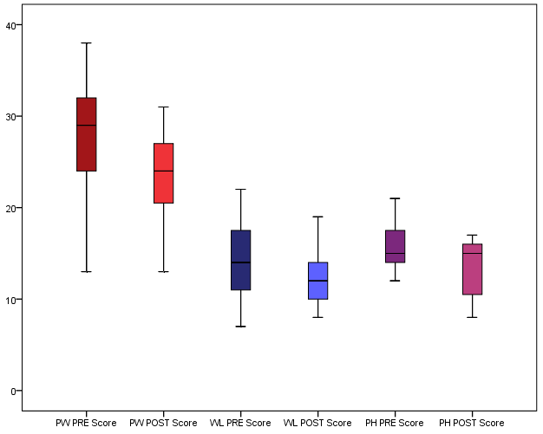
FIG.1. Changes in Psychological Wellbeing, Work life Balance and Physical Health expressed as Pre and Post Programme ASSET Scores. Median displayed as the middle line within the box, interquartile ranges displayed as the box and maximum and minimum values displayed as the whiskers.
Significance results are annotated as follows: *p=<0.05, **p=<0.01, ***p=<0.005.

**
*
***

Activity Levels
Participants demonstrated an increased number of steps taken per day when compared to the national UK average. There was a large variation in number of steps taken and on what days, with some participants falling below national average on occasions. No significance in number of steps taken over the duration of the study (p = 0.444).
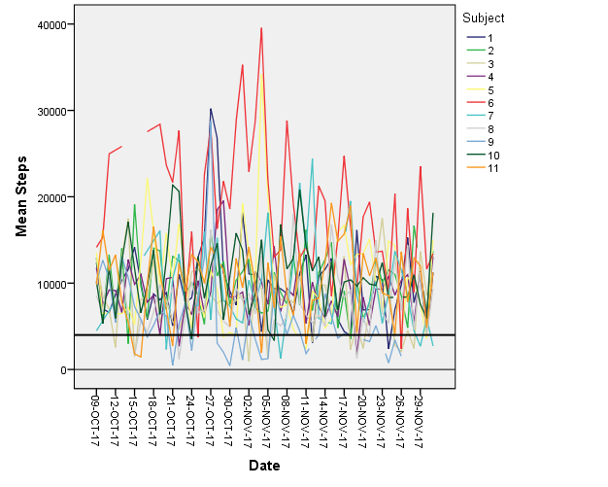
Fig.2. Total steps taken per day by each of the 11 participants plotted over the duration of the eight-week programme, compared to the average number of steps taken per day by UK adults (NHS Statistics, reference: thick black line).

The average steps taken on each day by the study participants was consistently higher than the UK national average (fig 3). However, the participants did not always achieve an average of the NHS daily recommended steps which is 10,000.

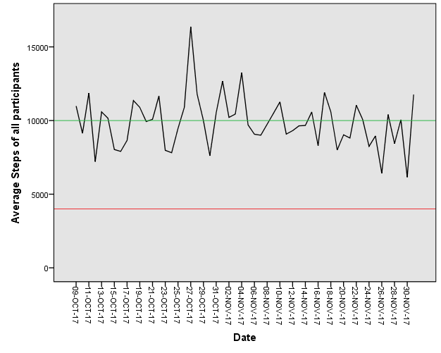
Fig.3. Average steps taken per day of all participants plotted over the duration of the eight-week programme, compared to the average number of steps taken per day by UK adults (ref: red Line) (NHS Statistics) and recommended number of steps taken per day for UK adults (NHS/CDC) (ref: green line).

Activity levels of participants were recorded as ‘fairly active’ (equivalent to NHS’ moderately active) and ‘very active’(Equivalent to NHS’ vigorously active). With the highest achieving an average of 31 minutes fairly active and 79 minutes very active per day which equates to 217 minutes moderately active and 553 minutes vigorously active per week. Lowest average activity scores from a participant still exceeded 105 minutes of vigorous activity per week and 49 minutes’ moderate activity per week.
Figure.3. Average duration and intensity of exercise per day each participant achieved throughout the duration of the programme. With a reference line of the recommended NHS target. Blue = Vigorously Active, Green = Moderately Active.
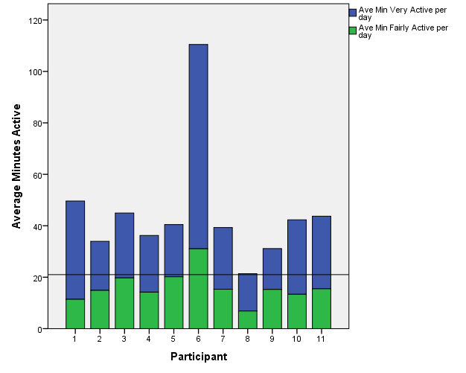
Figure.4. Average duration and intensity of exercise per day each participant achieved throughout the duration of the programme. With a reference line of the recommended NHS target. Blue = Vigorously Active, Green = Moderately Active.

HRV
HRV showed a median±SD of 58 ± 4.58 with an interquartile range maximum of 74 and a minimum of 42. There was no significant change in HRV trend throughout the study (p = 0.5490).

Fig.5. Average HRV trend, plus individual range, of all participants throughout the 8-week exercise programme. No significant trend was identified.

Discussion
Overview of results
The aim of the study was to determine if ‘non-exercising’ veterinary students can improve their psychological wellbeing, work life balance and physical health on completing an 8-week exercise programme. We also hypothesised that through exercise we would increase HRV and therefore increase robustness to everyday stressors. All participants that completed the exercise programme achieved and exceeded NHS recommended activity levels per week. After completing the programme, we can accept our hypothesis that perceived Psychological Wellbeing, Work life balance and Physical Health all significantly improved. However, there was no significant change in Heart Rate Variability over the course of the study so we have to reject our second hypothesis.
Achieving NHS Guided Activity Levels
NHS and CDC guidelines state healthy adults should aim to achieve, ‘150 minutes moderate exercise per week’ or ’75 minutes vigorous exercise per week’. Which equates to either an average of 22 minutes ‘Fairly active’ per day or an average of 11 minutes ‘Very Active’ per day or any combination of the two intensities. As seen in Fig.4. every participant exceeded this guideline.
The aim of 10,000 steps per day was not consistently reached by all participants however, the average steps by participants was distinctly higher than the UK average and therefore due to our selection criteria we can assume distinctly higher than pre-study. These levels of activity achieved by participants are considerable as only three 45 minute to 1 hour sessions were held each week and alone would not cause the averages to be this high. Thus demonstrating that participants were increasing their activity on days where sessions were not held, suggesting they were becoming more habitual exercisers outside of the programme, possibly finding motivation through peers (Vazou et al 2006) and continuing for enjoyment (Ryan et al. 1997). However, not all participants attended every session and all participants did a variety of activities outside of the study and with varying intensity, therefore, the impact of the effect of exercise will vary somewhat between individuals.
ASSET Scores
Psychological Wellbeing
In our study population, the Median pre study ASSET score for psychological wellbeing was 29, when the same ASSET questionnaire was performed involving 188 vet students the average score was 27 (Rose et al. 2017) and national average for non-managerial professionals was 23 (RobertsonCooper Ltd.). This shows that our selection criteria of non-exercisers have selected for a group with worse psychological wellbeing that that of their peers, however, it is acknowledged that the study population will have a degree of bias, given that we required a group of people willing to commit to an exercise programme. In Rose and colleagues’ study they described vet students’ psychological wellbeing score as ‘in the highest category indicating the poorest mental wellbeing’, when compared to background ASSET data presented by RobertsonCooper Ltd. However, after completing the exercise programme, the cohort’s psychological wellbeing score had significantly decreased with a median of 24 which was lower than that of Rose’s study average of 27. These results support a recent study of similar nature, whereby they conducted an eight-week training programme consisting of two, seventy-five minute sessions per week, on patients with mood disorders. The study concluded that physiological, biological and psychological profiles improved in patients with mood disorders following the exercise programme (Leone et al. 2018).
83% of veterinary students’ attribute study pressures and deadlines as a major stressor (AVS/BVA Survey 2016), at the time of the Pre Study ASSET these pressures would be much reduced compared to at the time of the Post Study ASSET due to increased academic workload developing throughout the programme.
Therefore, from this we can conclude that psychological wellbeing has improved from the start of the eight-week training programme to the completion. However, we cannot conclude that physical activity is the sole reason for this reduction.
Being part of the programme participants met regularly and soon developed a peer support group for themselves, they also had a social media platform to share experiences. It has been shown that peer group support and sharing experiences can help reduce stress and improve wellbeing and self-management (Mental Health Foundation, McLean et al. 2012). Other studies suggest that just being part of a support group and offering support to others may be even more important than receiving it (Brown et al. 2003).
During the programme participants attended two group and one individual wellbeing coaching sessions as part of a parallel study. The impact of coaching has also been extensively reported to improve perceptions of one’s own wellbeing (Hicks et al. 2013). On exiting the study participants reported that the developmental coaching was of help in managing stress and that exercising in groups gave participants confidence to share and support others in coaching sessions. Although reported to be of importance, the degree to which they influenced the results compared to exercise alone is unknown.

Work Life Balance
Pre ASSET median score for work life balance was 14, which according to RobertsonCooper Ltd. background data is ‘Poor’. This is unsurprising given BVA/AVS survey 2016 stated 58% of veterinary students suffered from a lack of free time, and poor work life balance is a well-documented source of stress (Bartram and Baldwin 2008, 2010, VetFutures 2015). However, even though adding in extra exercise sessions, participants felt their work life balance had significantly improved with a Post ASSET median score of 12. This confirms our hypothesis and other research such that non-work related outlets such as exercise improve work life balance (Mazerolle and Goodman, 2013).
Physical Health
For this study, it is important to remember physical health was not described as physical fitness, it refers to the impact of chronic stress on the body, such as headaches, muscle tension/ aches and back pain (Carlson et al. 2004). There was a significant reduction in perceived physical symptoms of stress from start to end of the study confirming that exercise reduces perceived physiological symptoms of stress (Salmon 2001, NHS Choices 2014), although the median value did not change overall. This may be due to chronic nature of some of the symptoms and the longer they take to resolve. It is also worth noting that most individuals had not previously consistently exercised and therefore their bodies will also have taken longer to recover (Tomlin and Wenger 2001) causing muscle aches and pain to persist following exertion. It is possible these were attributed in the Post study ASSET survey to stress related cause, reducing the significance of our result. Future studies could include biological markers for physical health, for example functional capacity of individuals or assessments by medically trained professionals to see any clinical improvement.
Heart Rate Variability
There was no change in average HRV across the programme for participants therefore we found no correlation between increased exercise and increased HRV. This is contrary to existing evidence (Stein et al. 1999, Atlini 2015a, Atlini 2015b) and there are several reasons why this could be the case. Previous studies into exercise and HRV trends have been over a longer period of time for example 6-12 months (Stein et al 1999, Atlini 2015b) and measures taken more frequently to increase reliability (Atlini 2015b). It is likely that in our study, the acute drop in HRV that occurs the day post exercise, due to recovery from physical stress as previously reported (Atlini 2015a), has caused the overall trend of HRV not to change. However, if the study had been over a longer duration with increased periods of recovery after physical exercise we would hypothesise a trend increase in HRV at rest.

Conclusion
On completing an eight-week group exercise programme this study demonstrates a significant improvement in psychological wellbeing, perceived work life balance and improved physical health in a group of previously ‘non-exercising’ veterinary students. No change of HRV was demonstrated. From these results, it can be suggested that a possible solution to the previously demonstrated poor psychological wellbeing, work life balance and physical health of veterinary students (Rose et al. 2017) is an increase in activity level. It is arguable that universities have a responsibility to be doing more to combat high rates of mental ill health in veterinary students. A potential method for doing this could be, more emphasis/ provision for increasing exercise and creating environments where peers of all exercise experience can train and support each other, curriculum design should include time set aside for non-cognitive pursuits. In doing so prevent and reduce psychological and physiological symptoms of stress and possibly reverse the trend of mental ill-health within veterinary students.
Further research into the impact exercise has on psychological wellbeing, work life balance and physical health could be extended into the Veterinary profession as there are equally worrying, and more severe trends of poor mental health within practising vets (Rose et al. 2017).
Acknowledgements
I would like to thank all participants for their effort and commitment throughout the study, instructors and facilitators in organising the training programme and finally Prof. Renate Weller for supervision of the project. This project was funded by the LIVE Teaching Development Team Award 2017.

Word Count: 3955

References
AGERBO, E., GUNNELL, D., BONDE, J.P., MORTENSON, P.B. & NORDENTOFT, M. (2007) Suicide and occupation: the impact of socio-economic, demographic, and psychiatric difference. Psychological Medicine 37, 1131-1140
ALEXANDRATOS, K., BARNETT, F. & THOMAS, Y. (2012). The impact of exercise on the mental health and quality of life of people with severe mental illness: a critical review. British Journal of Occupational Therapy, 75 (2), 48–60.
ALTINI, M. (2015a). Acute changes in heart rate variability. http://www.hrv4training.com/blog/acute-changes-in-heart-rate-variability
ALTINI, M. (2015b). Interpreting HRV trends. http://www.hrv4training.com/blog/interpreting-hrv-trends
BARTRAM, D.J. & BALDWIN, D.S. (2008) Veterinary surgeons and suicide: influences, opportunities and research directions. Veterinary Record. 162, 36-40
BARTRAM, D.J. & BALDWIN, D.S. (2010) Veterinary surgeons and suicide: a structured review of possible influences on increased risk. Veterinary Record 166, 388-397.
BROWN, S.L., NESSE, R.M. VINOKUR, A.D., and SMITH, D.M. (2003). Providing social support may be more beneficial than receiving it: Results from a prospective study of mortality. Psychological Science 14(4), 320-327.
British Veterinary Association and the Association of Veterinary Students, Survey results (2016) Sponsored by Vets4Pets
CARDWELL J., LEWIS E., SMITH K., HOLT E., BAILLIE S., ALLISTER R. & ADAMSuh V. (2013) A cross-sectional study of mental health in UK veterinary undergraduates. Veterinary Record doi: 10.1136/vr.10139
CARDWELL, JM & LEWIS EG (2017) Vocation, belongingness and balance: a qualitative study of veterinary student well-being J Vet Med Educ. Spring;44(1):29-37
CARTWRIGHT, S., & COOPER, C. L. (2002). ASSET: Management guide. RobertsonCooper Ltd, UK’
CARLSON N. R. (2004). Physiology of behavior, 8th ed. New York: Allyn & Bacon.
de Vries JD¹, van Hooff ML¹, Geurts SA¹, Kompier MA¹. (2016) Exercise as an Intervention to Reduce Study-Related Fatigue among University Students: A Two-Arm Parallel Randomized Controlled Trial. PLoS One. Mar 31;11(3):e0152137.
FARAGHER, E.B., COOPER, C.L. & CARTWRIGHT S. (2004) A Shortened Stress Evaluation Tool (ASSET). Stress and Health 20, 189-201
FITBIT.COM (https://help.fitbit.com/articles/en_US/Help_article/1379) [Accessed on 14/01/2018]
GELBERG, S. & GELBERG, H. (2005) Stress management interventions for veterinary students. Journal of Veterinary Medical Education, 32, 173–181
GOUIN, J.P., DESCHENES, S.S., DUGAS, M.J. (2014) Respiratory sinus arrhythmia during worry forecasts stress-related increases in psychological distress. 10.3109/10253890.2014.949666
GOLDBERG, D.P., GATER, R., SARTORIUS, N. & USTUN, T.B. (1997), The validity of two versions of the GHQ in the WHO study of mental illness in general health care. Psychological Medicine, 27, pp. 191-7.
HALLIWELL, R.., DOWNES, M., ADAMS, VJ., ALLISTER, R., HARRISON, W., MELLANBY, RJ., DEAN, RS. (2016) Stress in new graduates: can the profession do more to help? Veterinary Record 178, 635-636.
HARMELINK, A.J., (2016) Effects of Heart Rate Variability Biofeedback on Perceived Stress, Perceived Coping Ability and Resilience in Accelerated Baccalaureate Nursing Students. Ph.D. Dissertation, Major Nursing, South Dakota State University
HEATH, TJ. The more things change, the more they should stay the same. J Veterinary Medical Education 2006; 33:149-154
HICKS. B., CARTER. A., SINCLAIR. A. (2013) Impact of coaching: An empirical longitudinal study into coachee well-being, engagement and job satisfaction following a coaching programme at work. IES Research Network project
HSE.GOV.UK. http://www.hse.gov.uk/stress/furtheradvice/whatisstress.htm [Accessed on 06/03/2017]
JOHNSON, S. AND COOPER, C. (2003) The construct validity of the ASSET stress measure. Stress and Health, 19, pp. 181-5
JOHNSON, S., COOPER, C. L., CARTWRIGHT, S., DONALD, I., TAYLOR, P., & MILLET, C. (2005). The experience of work-related stress across occupations. Journal of Managerial Psychology, 20, 179 – 187.
LEONE, M, LALANDE, D, THERIAULT, L, KALINOVA, É, FORTIN, A. (2018) Effects of an exercise program on the physiological, biological and psychological profiles in patients with mood disorders: a pilot study. Int J Psychiatry Clin Pract. 15:1-6. doi: 10.1080/13651501.2018.1425458
MAZEROLLE. S.M., GOODMAN. A. (2013) Fulfillment of work-life balance from the organizational perspective: a case study. J Athl Train. Sep-Oct;48(5):668-77. doi: 10.4085/1062-6050-48.3.24.
MCLEAN, J., WOODHOUSE. A., BIGGS. H., BOWIE, J. (2012) Exploring peer support as an approach to supporting self-management. Mental Health Foundation.
MELLANBY, R.J. (2005) Incidence of suicide in the veterinary profession in England and Wales. Veterinary Record 157, 415-417.
Mental Health Foundation. https://www.mentalhealth.org.uk/
NHS CHOICES (2014). “Struggling with stress?” Available at: http://www.nhs.uk/conditions/stress-anxiety-depression/pages/understanding-stress.aspx [Accessed on 06/03/17].
NHS CHOICES (2016) The placebo effect and complementary and alternative medicine. http://www.nhs.uk/Livewell/complementary-alternative-medicine/Pages/placebo-effect.aspx
PENGPID S, PELTZER, K. (2018) Vigorous physical activity, perceived stress, sleep and mental health among university students from 23 low- and middle-income countries. International Journal of Adolescent Medicine and Health. pii: /j/ijamh.ahead-of-print/ijamh-2017-0116/ijamh-2017-0116.xml. doi: 10.1515/ijamh-2017-0116
ROBINSON, D. & HOOKER, H. (2006) The UK veterinary profession in 2006 Ed Royal College of Veterinary Surgeons. Institute for Employment Studies, London
ROSE, H.A., WELLER, R., (2017) Is there a Relationship Between Stress and Exercise Within the Veterinary Profession? RVC Research Project 2.
ROSENBAUM, S., TIEDEMANN, A., & SHERRINGTON, C. (2014). Physical activity interventions for people with mental illness: a systematic review and meta-analysis. J Clin Psychiatry, 75:964–74.
RYAN, R.M., FREDERICK, C.M., LEPES, D., RUBIO, N and SHELDON, K.M. (1997) Intrinsic motivation and exercise adherence. International Journal of Sport Psychology 28, 335-354
SALMON, P. (2001). Effects of Physical Activity on Anxiety, Depression, and Sensitivity to Stress: A Unifying Theory. Clinical Psychology Review, 21 (1), 33–61.
Sandars J & Cleary T J (2011) Self-regulation theory: Applications to medical education: AMEE Guide No. 58 Medical Teacher 33: 875-886
SCHUCH, F., VANCAMPFORT, D., RICHARDS, J., ROSENBAUM, S., WARD, P. & STUBBS, B. (2016) Exercise as a treatment for depression: A meta-analysis adjusting for publication bias. Journal of Psychiatric Research, 77, 42-51
STEIN, P.K., EHSANI, A.A., DOMITROVICH, P.P., KLEIGER, R.E., ROTTMAN, J.N. (1999) Effect of exercise training on heart rate variability in healthy older adults. American Heart Journal 138, Issue 3, Pages 567-576

TOMLIN. D.L., WENGER. H.A. (2001) The Relationship Between Aerobic Fitness and Recovery from High Intensity Intermittent Exercise. Sports Medicine. Vol 31:1, pp 1-11.
VAZOU, S., NTOUMANIS, N., DUDA, J.L. (2006) Predicting young athletes’ motivational indices as a function of their perceptions of the coach- and peer-created climate. Psychology of Sport and Exercise 7, 215-233.
VETFUTURES (2015) Vet Futures. http://vetfutures.org.uk.
WANKEL, L. M. (1993). The importance of enjoyment to adherence and psychological benefits from physical activity. International Journal of Sport Psychology, 24(2), 151-169.
ZSCHUCKE, E., GAUDLITZ, K. & STROHLE, A. (2013). Exercise and Physical Activity in Mental Disorders: Clinical and Experimental Evidence. J Prev Med Public Health, 46 (1), 512–521.

