Presentation
This module will address the presentation of written assignments.

The way that your work is presented is very important from a number of different viewpoints. It gives the reader their first impression of the assignment and we all know how important first impressions can be. The presentation can also make an assignment more readable, helping you to get your point across. It can also provide better access to specific information that a reader may be looking for.

When presenting your assignment you may be required to follow guidelines provided by your course administrators. Guidelines can be at an Institute level, but you may also be given specific instructions from your tutor. There will be room for you to make some decisions as to how your assignment looks. However, you should always follow any guidelines that are provided.

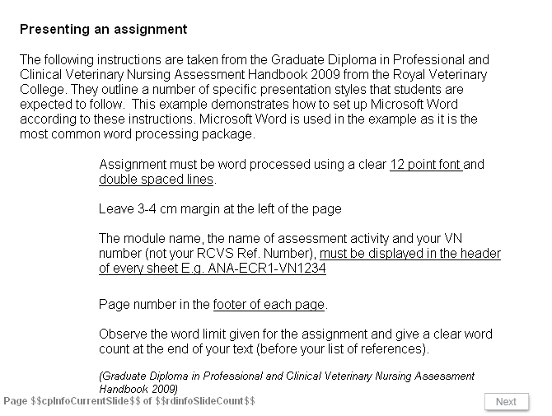
Slide 1
Presenting an assignment

The following instructions are taken from the Graduate Diploma in Professional and Clinical Veterinary Nursing Assessment Handbook 2009 from the Royal Veterinary College. They outline a number of specific presentation styles that students are expected to follow. This example demonstrates how to set up Microsoft Word according to these instructions. Microsoft Word is used in the example as it is the most common word processing package.

Assignment must be word processed using a clear 12 point font and double spaced lines.

Leave 3-4 cm margin at the left of the page

The module name, the name of assessment activity and your VN number (not your RCVS Ref. Number), must be displayed in the header of every sheet E.g. ANA-ECR1-VN1234
Page number in the footer of each page.

Observe the word limit given for the assignment and give a clear word count at the end of your text (before your list of references).
(Graduate Diploma in Professional and Clinical Veterinary Nursing Assessment Handbook 2009)

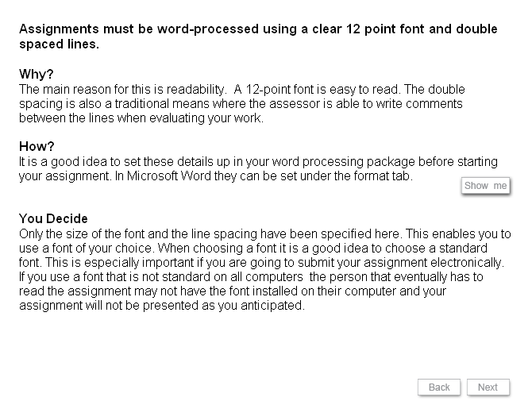
Slide 2
Assignments must be word-processed using a clear 12 point font and double spaced lines.

Why?
The main reason for this is readability. A 12-point font is easy to read. The double spacing is also a traditional means where the assessor is able to write comments between the lines when evaluating your work.

How?
It is a good idea to set these details up in your word processing package before starting your assignment. In Microsoft Word they can be set under the format tab.

You Decide
Only the size of the font and the line spacing have been specified here. This enables you to use a font of your choice. When choosing a font it is a good idea to choose a standard font. This is especially important if you are going to submit your assignment electronically. If you use a font that is not standard on all computers the person that eventually has to read the assignment may not have the font installed on their computer and your assignment will not be presented as you anticipated.

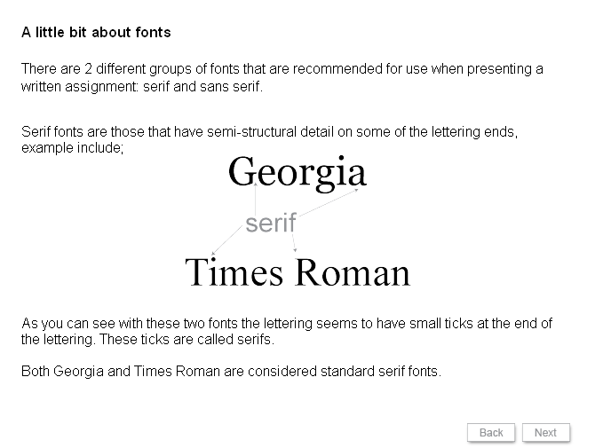
Slide 3
A little bit about fonts

There are 2 different groups of fonts that are recommended for use when presenting a written assignment: serif and sans serif.

Serif fonts are those that have semi-structural detail on some of the lettering ends, example include;

As you can see with these two fonts the lettering seems to have small ticks at the end of the lettering. These ticks are called serifs.

Both Georgia and Times Roman are considered standard serif fonts.

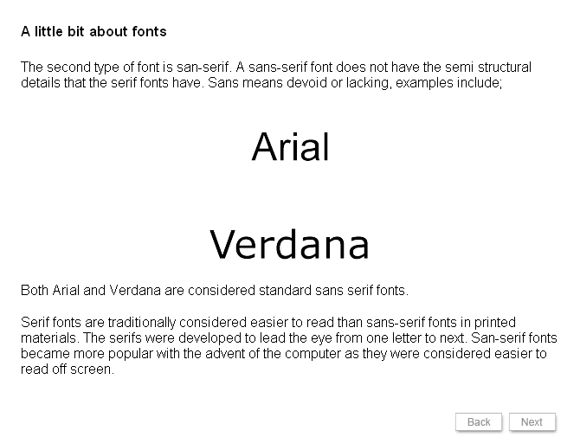
Slide 4
A little bit about fonts

The second type of font is san-serif. A sans-serif font does not have the semi structural details that the serif fonts have. Sans means devoid or lacking, examples include;

Both Arial and Verdana are considered standard sans serif fonts.

Serif fonts are traditionally considered easier to read than sans-serif fonts in printed materials. The serifs were developed to lead the eye from one letter to next. San-serif fonts became more popular with the advent of the computer as they were considered easier to read off screen.

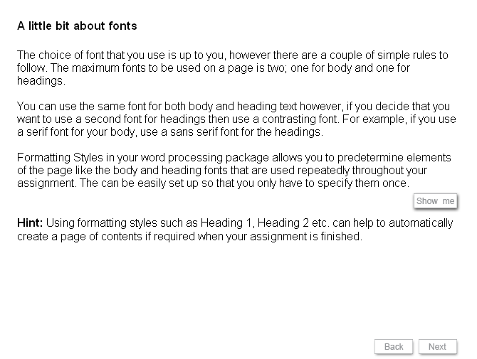
Slide 5
A little bit about fonts
The choice of font that you use is up to you, however there are a couple of simple rules to follow. The maximum fonts to be used on a page is two; one for body and one for headings.

You can use the same font for both body and heading text however, if you decide that you want to use a second font for headings then use a contrasting font. For example, if you use a serif font for your body, use a sans serif font for the headings.

Formatting Styles in your word processing package allows you to predetermine elements of the page like the body and heading fonts that are used repeatedly throughout your assignment. The can be easily set up so that you only have to specify them once.

Hint: Using formatting styles such as Heading 1, Heading 2 etc. can help to automatically create a page of contents if required when your assignment is finished.

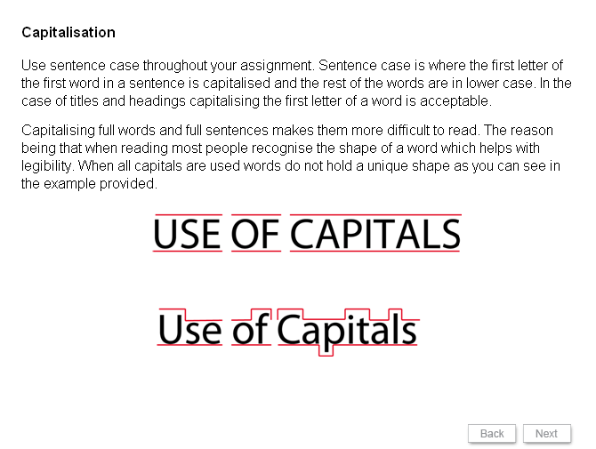
Slide 6
Capitalisation

Use sentence case throughout your assignment. Sentence case is where the first letter of the first word in a sentence is capitalised and the rest of the words are in lower case. In the case of titles and headings capitalising the first letter of a word is acceptable.
Capitalising full words and full sentences makes them more difficult to read. The reason being that when reading most people recognise the shape of a word which helps with legibility. When all capitals are used words do not hold a unique shape as you can see in the example provided.

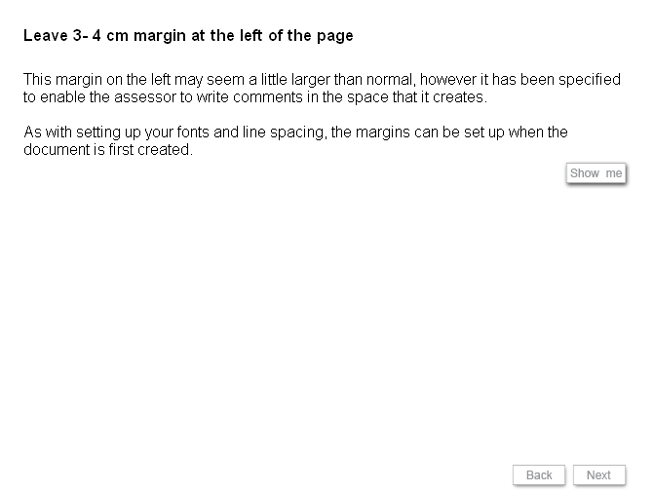
Slide 7
Leave 3- 4 cm margin at the left of the page
This margin on the left may seem a little larger than normal, however it has been specified to enable the assessor to write comments in the space that it creates.

As with setting up your fonts and line spacing, the margins can be set up when the document is first created.

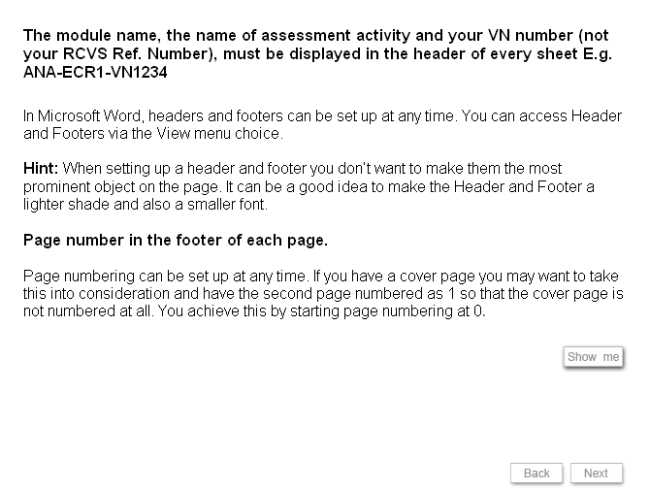
Slide 8
The module name, the name of assessment activity and your VN number (not your RCVS Ref. Number), must be displayed in the header of every sheet E.g. ANA-ECR1-VN1234

In Microsoft Word, headers and footers can be set up at any time. You can access Header and Footers via the View menu choice.

Hint: When setting up a header and footer you don’t want to make them the most prominent object on the page. It can be a good idea to make the Header and Footer a lighter shade and also a smaller font.

Page number in the footer of each page.

Page numbering can be set up at any time. If you have a cover page you may want to take this into consideration and have the second page numbered as 1 so that the cover page is not numbered at all. You achieve this by starting page numbering at 0.

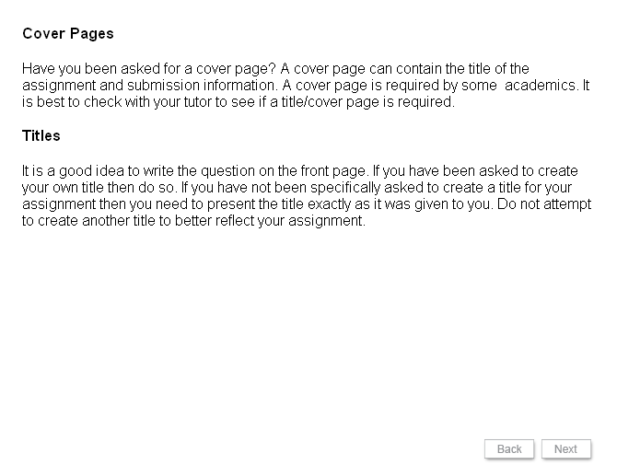
Slide 9
Cover Pages

Have you been asked for a cover page? A cover page can contain the title of the assignment and submission information. A cover page is required by some academics. It is best to check with your tutor to see if a title/cover page is required.

Titles

It is a good idea to write the question on the front page. If you have been asked to create your own title then do so. If you have not been specifically asked to create a title for your assignment then you need to present the title exactly as it was given to you. Do not attempt to create another title to better reflect your assignment.

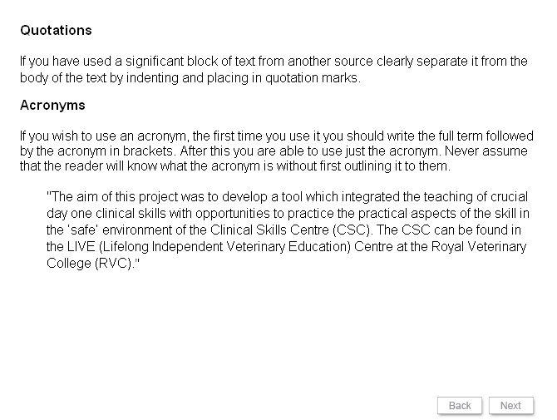
Slide 10
Quotations
If you have used a significant block of text from another source clearly separate it from the body of the text by indenting and placing in quotation marks.

Acronyms
If you wish to use an acronym, the first time you use it you should write the full term followed by the acronym in brackets. After this you are able to use just the acronym. Never assume that the reader will know what the acronym is without first outlining it to them.

"The aim of this project was to develop a tool which integrated the teaching of crucial day one clinical skills with opportunities to practice the practical aspects of the skill in the ‘safe’ environment of the Clinical Skills Centre (CSC). The CSC can be found in the LIVE (Lifelong Independent Veterinary Education) Centre at the Royal Veterinary College (RVC)."

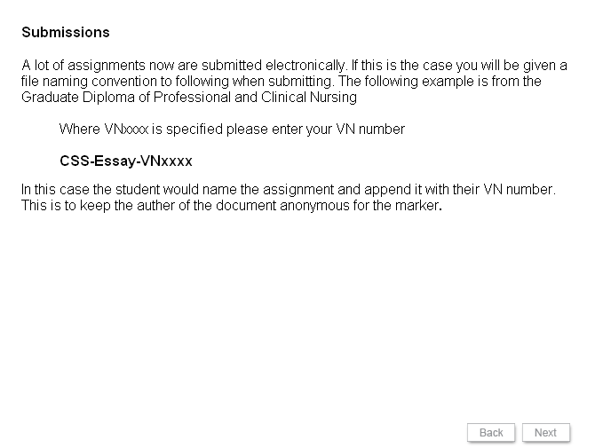
Slide 11
Submissions

A lot of assignments now are submitted electronically. If this is the case you will be given a file naming convention to following when submitting. The following example is from the Graduate Diploma of Professional and Clinical Nursing

Where VNxxxx is specified please enter your VN number

CSS-Essay-VNxxxx
In this case the student would name the assignment and append it with their VN number. This is to keep the auther of the document anonymous for the marker.

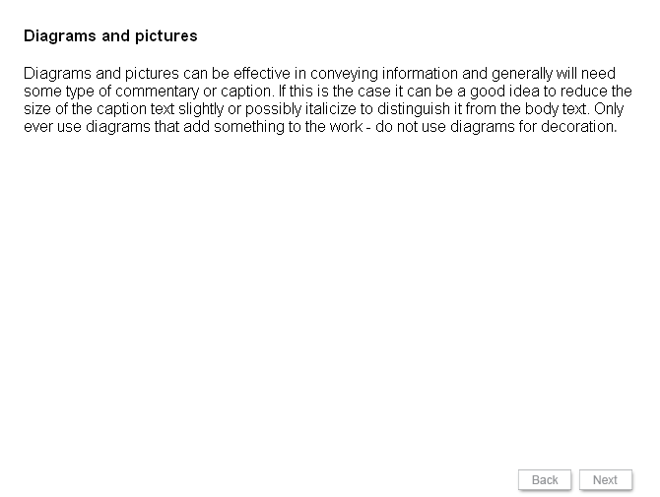
Slide 12
Diagrams and pictures

Diagrams and pictures can be effective in conveying information and generally will need some type of commentary or caption. If this is the case it can be a good idea to reduce the size of the caption text slightly or possibly italicize to distinguish it from the body text. Only ever use diagrams that add something to the work - do not use diagrams for decoration.

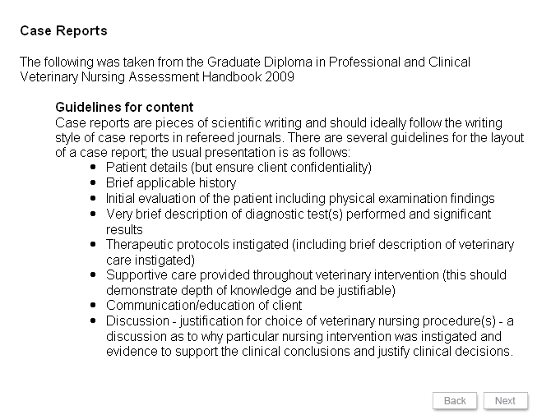
Slide 13
Case Reports
The following was taken from the Graduate Diploma in Professional and Clinical
Veterinary Nursing Assessment Handbook 2009

Guidelines for content
Case reports are pieces of scientific writing and should ideally follow the writing style of case reports in refereed journals. There are several guidelines for the layout of a case report; the usual presentation is as follows:
- Patient details (but ensure client confidentiality)
- Brief applicable history
- Initial evaluation of the patient including physical examination findings
- Very brief description of diagnostic test(s) performed and significant results
- Therapeutic protocols instigated (including brief description of veterinary care instigated)
- Supportive care provided throughout veterinary intervention (this should demonstrate depth of knowledge and be justifiable)
- Communication/education of client
- Discussion - justification for choice of veterinary nursing procedure(s) - a discussion as to why particular nursing intervention was instigated and evidence to support the clinical conclusions and justify clinical decisions.

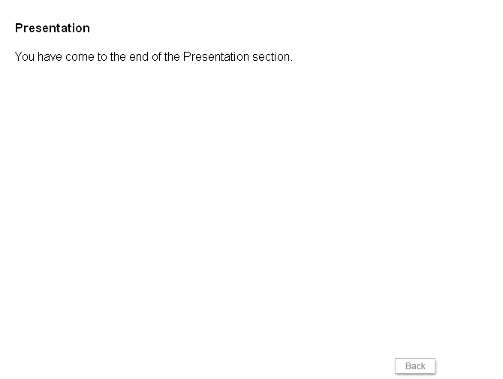
Slide 14
Presentation

You have come to the end of the Presentation section.

