The Right Word

In this module we are going to look at how using the right word can make a big difference to your academic writing. We will also remind you about areas in which you need to take extra care, for example with words that sound the same but have different meanings.

In academic writing it is really important to use the most appropriate words. Experienced writers seem to find the right words and put their points across clearly. You need practice to achieve this. In this module we point out some of the things to be aware of, in order to make the transition from a competent writer to one with good academic style.

A good academic style has clarity and conveys meaning precisely. It should not be pretentious or over complicated. Aim to stimulate your reader with clear, unambiguous and well-structured text.

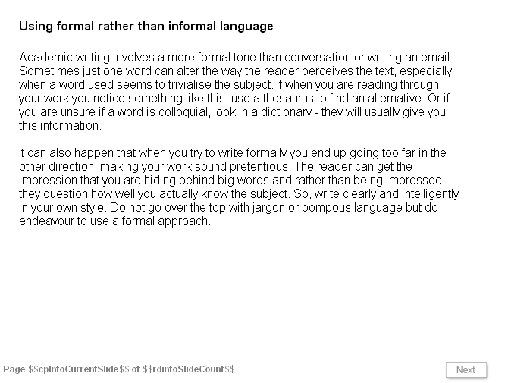
Slide 1
Using formal rather than informal language
Academic writing involves a more formal tone than conversation or writing an email. Sometimes just one word can alter the way the reader perceives the text, especially when a word used seems to trivialise the subject. If when you are reading through your work you notice something like this, use a thesaurus to find an alternative. Or if you are unsure if a word is colloquial, look in a dictionary - they will usually give you this information.

It can also happen that when you try to write formally you end up going too far in the other direction, making your work sound pretentious. The reader can get the impression that you are hiding behind big words and rather than being impressed, they question how well you actually know the subject. So, write clearly and intelligently in your own style. Do not go over the top with jargon or pompous language but do endeavour to use a formal approach.

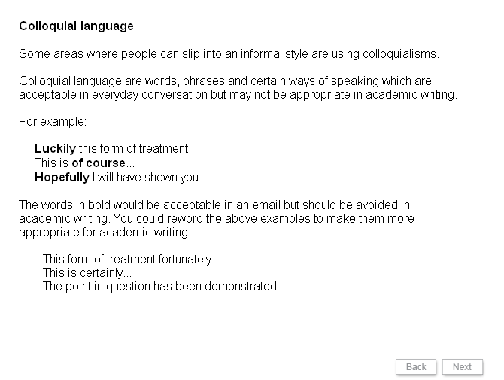
Slide 2
Colloquial language
Some areas where people can slip into an informal style are using colloquialisms.

Colloquial language are words, phrases and certain ways of speaking which are acceptable in everyday conversation but may not be appropriate in academic writing.

For example:

Luckily this form of treatment...
This is of course...
Hopefully I will have shown you...

The words in bold would be acceptable in an email but should be avoided in academic writing. You could reword the above examples to make them more appropriate for academic writing:

This form of treatment fortunately...
This is certainly...
The point in question has been demonstrated...

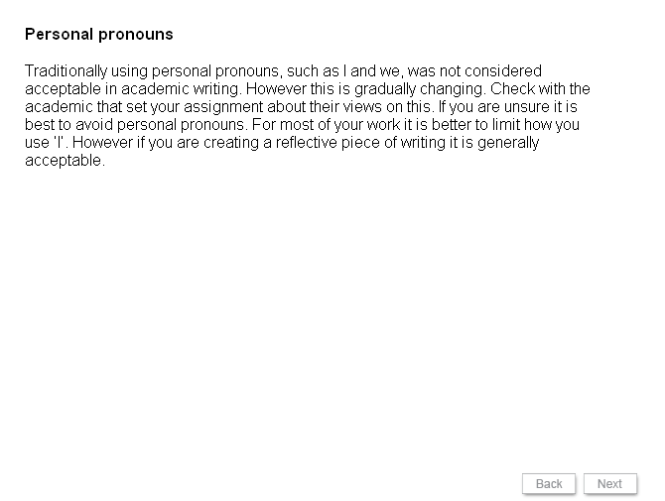
Slide 3
Personal pronouns
Traditionally using personal pronouns, such as I and we, was not considered acceptable in academic writing. However this is gradually changing. Check with the academic that set your assignment about their views on this. If you are unsure it is best to avoid personal pronouns. For most of your work it is better to limit how you use ‘I’. However if you are creating a reflective piece of writing it is generally acceptable.

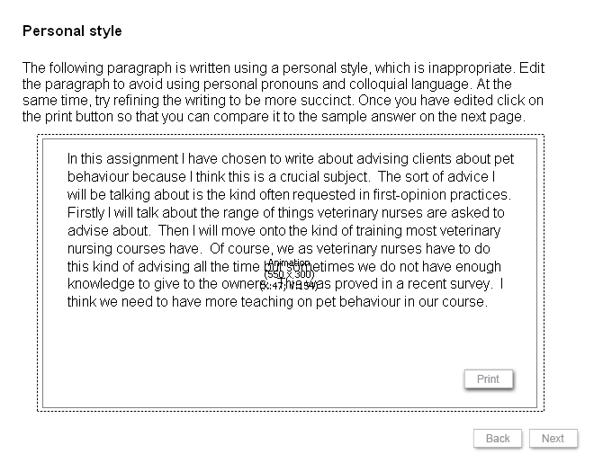
Slide 4
Personal style
The following paragraph is written using a personal style, which is inappropriate. Edit the paragraph to avoid using personal pronouns and colloquial language. At the same time, try refining the writing to be more succinct. Once you have edited click on the print button so that you can compare it to the sample answer on the next page.

In this assignment I have chosen to write about advising clients about pet behaviour because I think this is a crucial subject. The sort of advice I will be talking about is the kind often requested in first-opinion practices. Firstly I will talk about the range of things veterinary nurses are asked to advise about. Then I will move onto the kind of training most veterinary nursing courses have. Of course, we as veterinary nurses have to do this kind of advising all the time but sometimes we do not have enough knowledge to give to the owners. This was proved in a recent survey. I think we need to have more teaching on pet behaviour in our course.

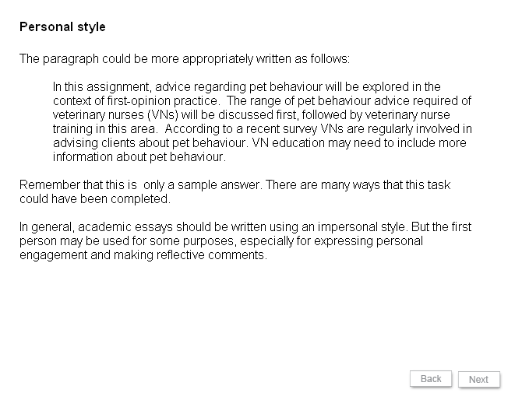
Slide 5
Personal style
The paragraph could be more appropriately written as follows:

In this assignment, advice regarding pet behaviour will be explored in the context of first-opinion practice. The range of pet behaviour advice required of veterinary nurses (VNs) will be discussed first, followed by veterinary nurse training in this area. According to a recent survey VNs are regularly involved in advising clients about pet behaviour. VN education may need to include more information about pet behaviour.

Remember that this is only a sample answer. There are many ways that this task could have been completed.

In general, academic essays should be written using an impersonal style. But the first person may be used for some purposes, especially for expressing personal engagement and making reflective comments.

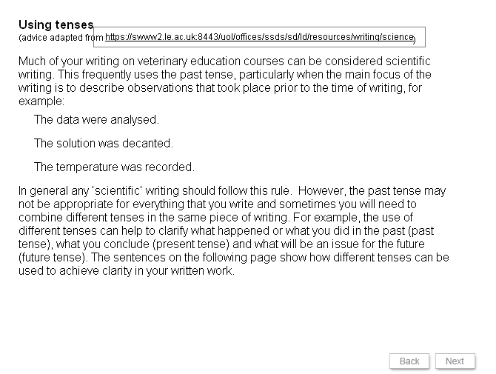
Slide 6
Using tenses
(advice adapted from https://swww2.le.ac.uk:8443/uol/offices/ssds/sd/ld/resources/writing/science)

Much of your writing on veterinary education courses can be considered scientific writing. This frequently uses the past tense, particularly when the main focus of the writing is to describe observations that took place prior to the time of writing, for example:
- The data were analysed.
- The solution was decanted.
- The temperature was recorded.
In general any ‘scientific’ writing should follow this rule. However, the past tense may not be appropriate for everything that you write and sometimes you will need to combine different tenses in the same piece of writing. For example, the use of different tenses can help to clarify what happened or what you did in the past (past tense), what you conclude (present tense) and what will be an issue for the future (future tense). The sentences on the following page show how different tenses can be used to achieve clarity in your written work.

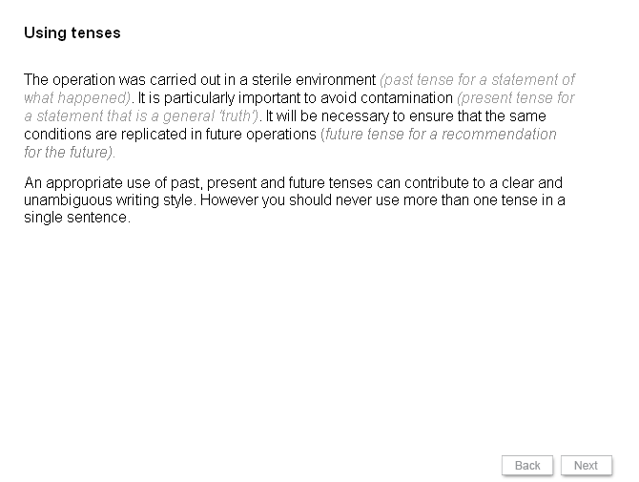
Slide 7
Using tenses
The operation was carried out in a sterile environment (past tense for a statement of what happened). It is particularly important to avoid contamination (present tense for a statement that is a general 'truth'). It will be necessary to ensure that the same conditions are replicated in future operations (future tense for a recommendation for the future).

An appropriate use of past, present and future tenses can contribute to a clear and unambiguous writing style. However you should never use more than one tense in a single sentence.

Slide 8
Which sentence uses tenses correctly?
- The VN plays an important role in feeding of patients; firstly he or she needs to be aware of when certain patients may require encouragement to feed or need to be tube fed; and report to the VS in charge of the case.
- The VN played an important role in feeding of patients; firstly he or she needs to be aware of when certain patients may require encouragement to feed or need to be tube fed; and reported to the VS in charge.

Answer available online.

Slide 9
Which of the following sentences use tenses correctly for a scientific report?
- Vascular access was obtained in a cephalic vein using an over the needle, 18 gauge catheter.
- Obtain vascular access in a cephalic vein using an over the needle, 18 gauge catheter.

Answer available online.

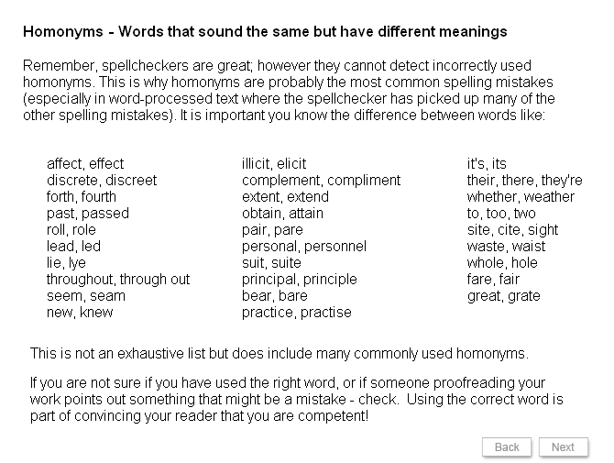
Slide 10
Homonyms - Words that sound the same but have different meanings

Remember, spellcheckers are great; however they cannot detect incorrectly used homonyms. This is why homonyms are probably the most common spelling mistakes (especially in word-processed text where the spellchecker has picked up many of the other spelling mistakes). It is important you know the difference between words like:

affect, effect  discrete, discreet  forth, fourth  past, passed  roll, role  lead, led  lie, lye  throughout, through out  seem, seam  new, knew | illicit, elicit  complement, compliment  extent, extend  obtain, attain  pair, pare  personal, personnel  suit, suite  principal, principle  bear, bare  practice, practise | it's, its  their, there, they're  whether, weather  to, too, two  site, cite, sight  waste, waist  whole, hole  fare, fair  great, grate

This is not an exhaustive list but does include many commonly used homonyms.
If you are not sure if you have used the right word, or if someone proofreading your work points out something that might be a mistake - check. Using the correct word is part of convincing your reader that you are competent!

Slide 11
Homonyms Identify which sentence is correct:

- Your responsible for choosing the correct word.
- You’re responsible for choosing the correct word.

Answers available online.

Slide 12
Homonyms Identify which sentence is correct:

- Weight gain can be a possible side affect.
- Weight gain can be a possible side effect.

Answer available online.

Slide 13
Homonyms Identify which sentence is correct:

- All sharps must be placed in the clinical waste.
- All sharps must be placed in the clinical waist.

Answer available online.

Slide 14
Homonyms Identify which sentence is correct:

- The brand of flea control chosen by the client can be a personal one.
- The brand of flea control chosen by the client can be a personnel one.

Answer available online.

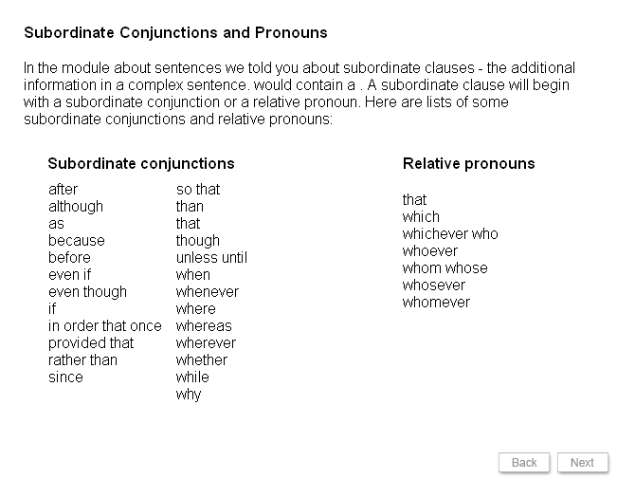
Slide 15
Subordinate Conjunctions and Pronouns

In the module about sentences we told you about subordinate clauses - the additional information in a complex sentence. A subordinate clause will begin with a subordinate conjunction or a relative pronoun. Here are lists of some subordinate conjunctions and relative pronouns.

Subordinate conjunctions |  | Relative pronouns
after  although  as  because  before  even if  even though  if  in order that once  provided that  rather than  since | so that  than  that  though  unless until  when  whenever  where  whereas  wherever  whether  while  why | that  which  whichever who  whoever  whom whose  whosever  whomever

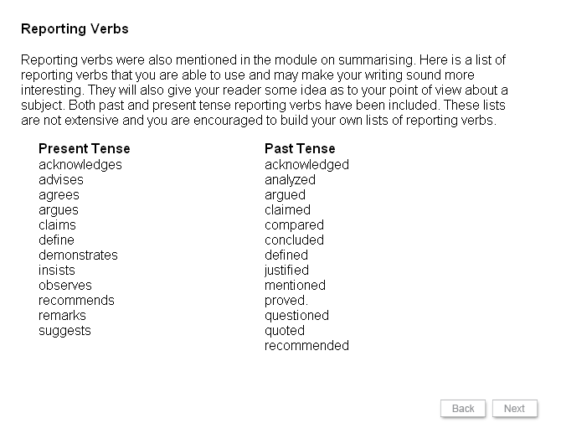
Slide 16
Reporting Verbs

Reporting verbs were also mentioned in the module on summarising. Here is a list of reporting verbs that you are able to use and may make your writing sound more interesting. They will also give your reader some idea as to your point of view about a subject. Both past and present tense reporting verbs have been included. These lists are not extensive and you are encouraged to build your own lists of reporting verbs.

Present Tense | Past Tense
acknowledges  advises  agrees  argues  claims  define  demonstrates  insists  observes  recommends  remarks  suggests | acknowledged  analyzed  argued  claimed  compared  concluded  defined  justified  mentioned  proved  questioned  quoted  recommended

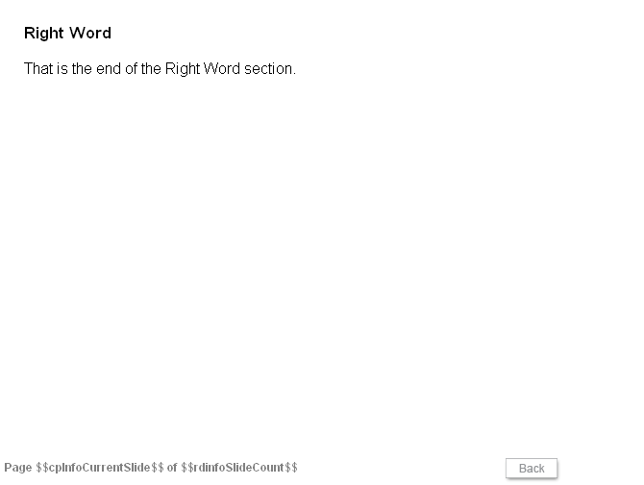
Slide 17
Right Word

That is the end of the Right Word section.

